**NIT6150 Advanced Project**

**User Manual**

**HealthCare Chatbot System**

**Team Leader:** Jitendra Shrestha (s8104215)

**Team Member:** Pranish Acharya (s8100698)

**Client:** Holroyd Private Hospital

**Supervisor:** Fakhra Jabeen

VU Sydney

**Steps for installing the System**

Clone the repo from provided link : <https://github.com/pranish33/Advance-Project.git>

Open the local drive where the system will be cloned to and open git bash on it

***git clone https://github.com/pranish33/Advance-Project.git***

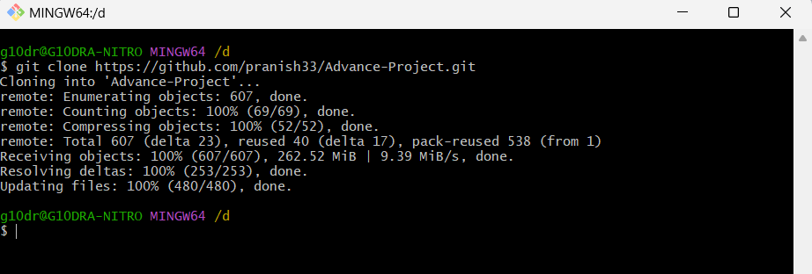

**Prerequisite**: python (3.8.0) is already setup successfully

To check

***python –version***

**Open the cloned project and open and please open the command line from bash and do the following commands as shown below:**

Create environment using Python virtual environment

python -m venv ‘***environment_name****’*

Activate the virtual environment

source ‘***environment_name***’ /Scripts/activate

Install RASA Framework using Python 3.8.0

pip install rasa [‘full’]

***This will take time so please wait until it completes.***

Install Django framework

pip install Django

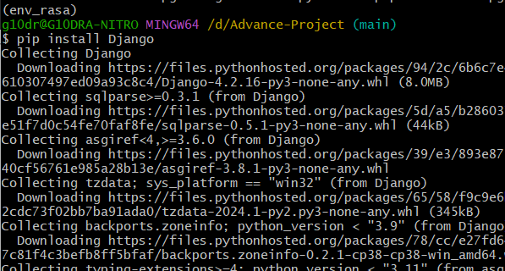

Get into the chatbot folder

cd Source\ Code/healthcarechatbotSystem/HealthBot/

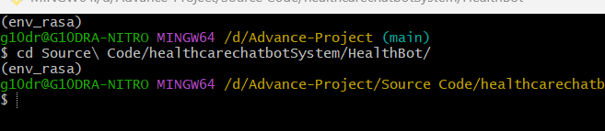

Train The model

rasa train

*This step is optional. As we have already trained the model that will take time for more accuracy. Also, if this command is done a new trained model will be used without any issue.*

Run the server

rasa run --enable-api –-cors=”*”

**For frontend we need to start different server**

Please open another terminal and activate the environment then follow below command

Run the frontend server

python manage.py runserver

Then from the browser with server will be ready

Now the frontend server and backend is also ready so Please go to the below URL from any web browser.

**URL: localhost:8000**

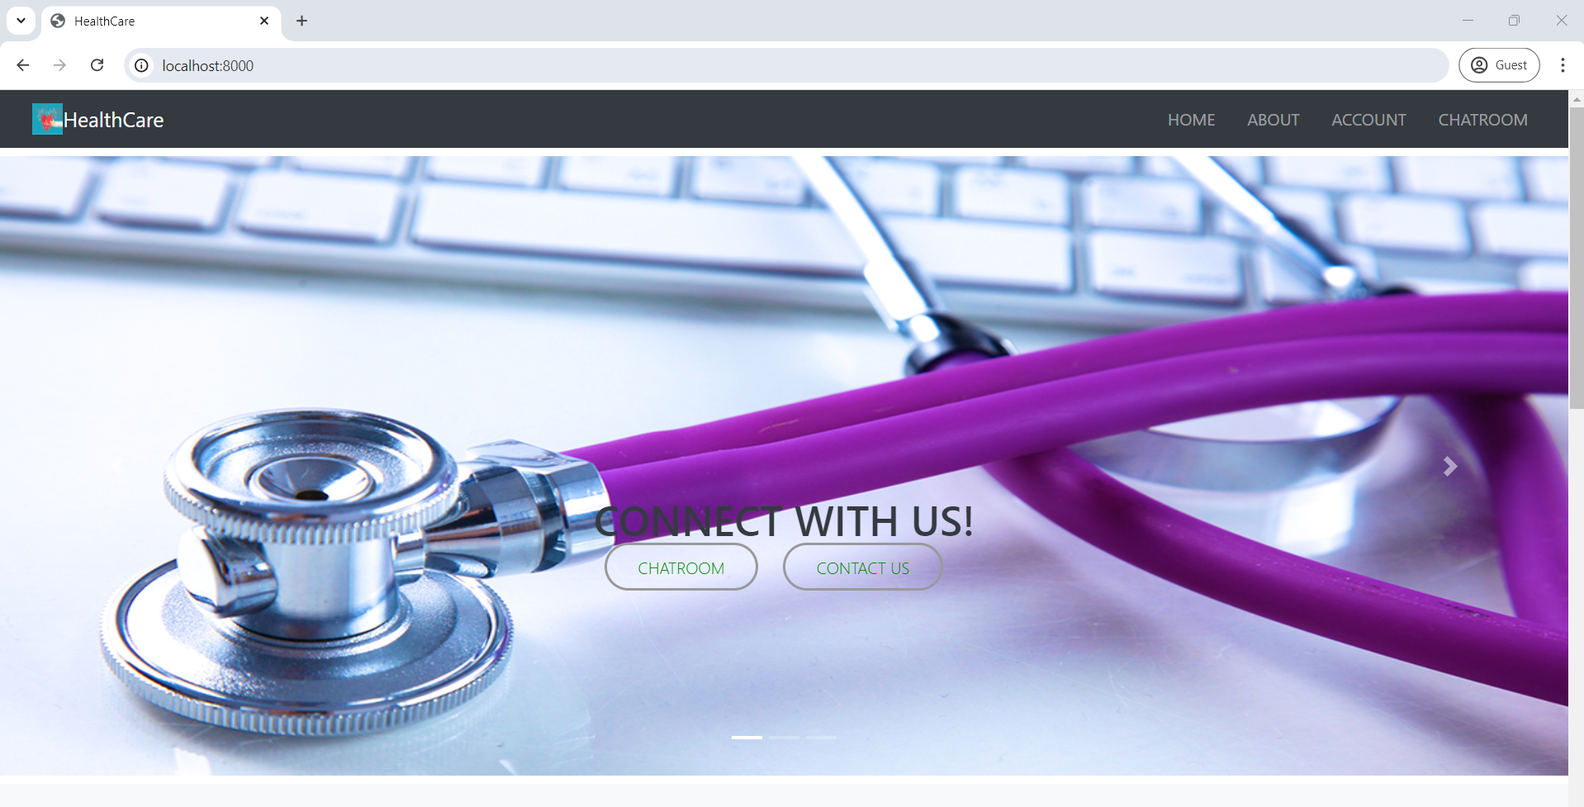

If you can’t see the provided screen you might have to check it from the command line.

**Also check the chatbot**

Also, we will be checking the database by logging in super user

**URL:** localhost:8000/admin

Use the credentials of superuser

***Username****: admin*

***Password****: admin*

The database is also working fine. So, try logging one through patient

**URL: localhost:8000**

***Username****: patient1@gmail.com*

***Password****: patient1*

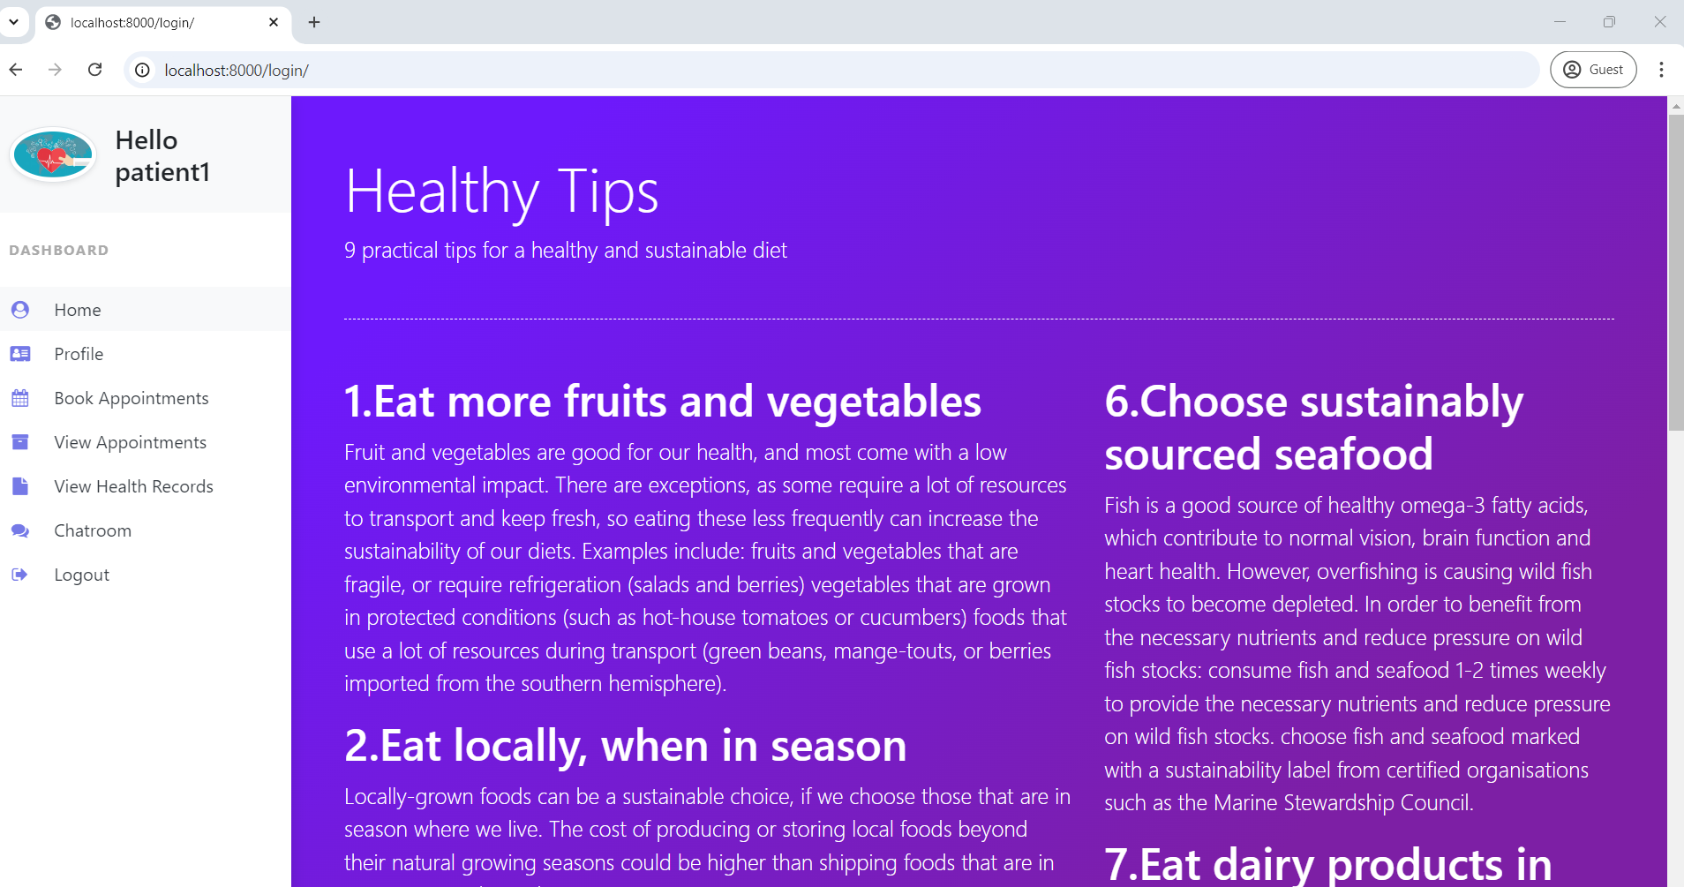

By verifying all the subsystem, we can know that system has been correctly installed in your machine.

**Stop the system by closing both the terminal window when finished**

**Some of the errors might be occur if any step is not working fine**

o   **KI1:** Database issues:

**Solution**: Need to migrate the model

o   **KI2:** Version issues:

**Solution**:  Need to downgrade the python if there is using higher versions

o   **KI3:** Sever issues:

**Solution**: Server might not be listening from backend

o   **KI4:** Backend issues:

**Solution**: RASA might not be supporting currently installed python

Python is not correctly installed and not available in PATH

***Please reach out to the team using above known issues code. In case the known issues are not found please raise a case with the screenshot of error from the command line.***